StarChip Enterprise at May Heydays 2025

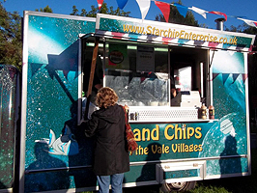 Friday 2 & Monday 5 May

**Fish & Chips**: *(GF batter option available)*

Award-winning Norwegian Cod or Haddock & Chips £14

Premium Scottish Scampi & Chips £10

Cod Roe & Chips £10  
Premium Scottish Fish cakes & Chips £10

Plant-based Nuggets & Chips £10 (Vegan)

**Sausages and Pies:**

German all-Pork premium Jumbo sausages £10 (+VG/Vegan options)

Tempura battered Halloumi Bon Bons £10 (VG)

Pukka Pies: £10

– select from Beef & onion, Chicken & Mushroom, Steak & Kidney, all Steak

**Burgers:** *all on buttery Brioche with Salad, slaw, onions, beef toms*

Double gourmet Cheeseburgers £10

Bombay Bad Boy Burgers £10 (Vegan, VG)

**Daily specials:** *See notice-board*

**Extras:** Triple cooked chips £4 Mushy peas £2

Buttered cobs £1 Curry sauce £2

With complimentary Heinz Ketchup, mayo, mustard, tartare plus other sauces and condiments

Full size Compostable forks & Compostable Boxes.

**Drinks:** All cans/water £2

Proprietor: Jeff Warren